AI LAB ASSIGNBMENT 8.1:

**NAME:M.VARSHITHA**

**: HALLTICKET NO:2403A52342**

**TASK 1**

write a python program to generate at least 3 assert test cases for is_strong_password(password) and implement the validator function. • Requirements: o Password must have at least 8 characters. o Must include uppercase, lowercase, digit, and special character.take user input o Must not contain spaces.Take 3 inputs

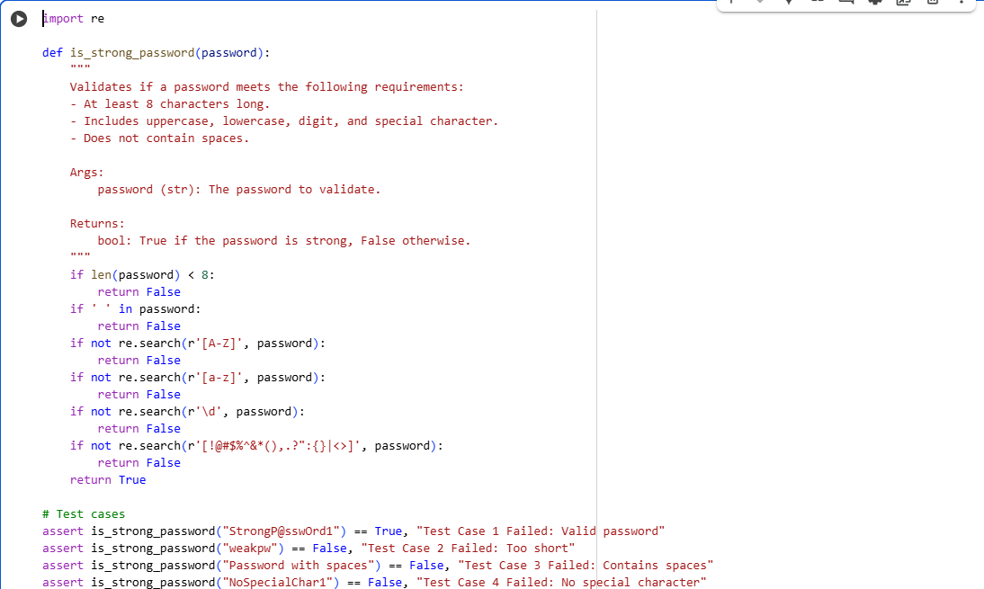

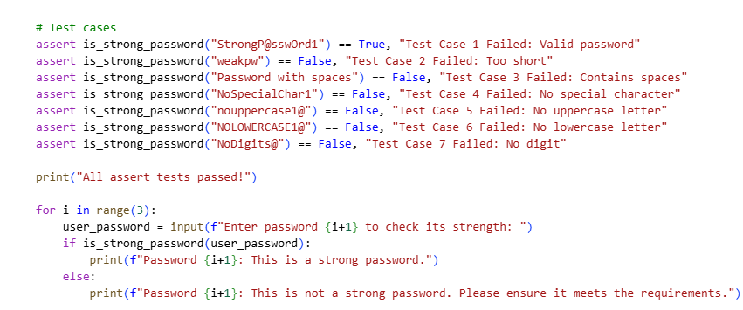

OUPUT:

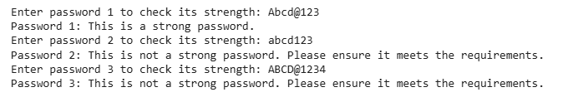

EXPLANATION:

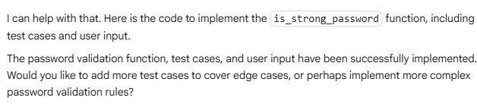

TASK 2:

write a python program to generate at least 3 assert test cases for a classify_number(n) function. Implement using loops. • Requirements: o Classify numbers as Positive, Negative, or Zero. o Handle invalid inputs like strings and None. o Include boundary conditions (-1, 0, 1).take 3 user inputs

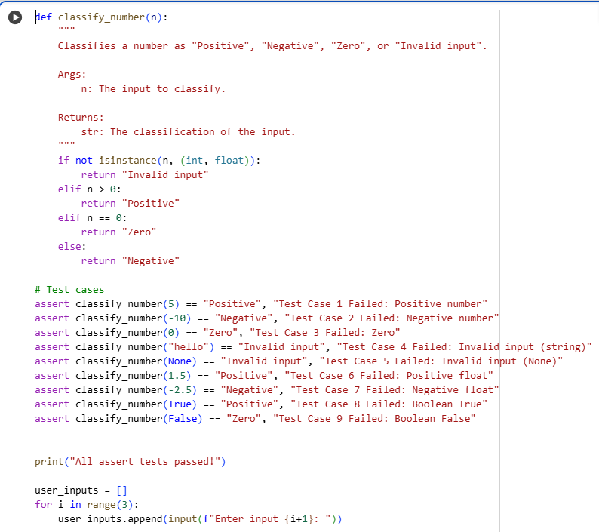

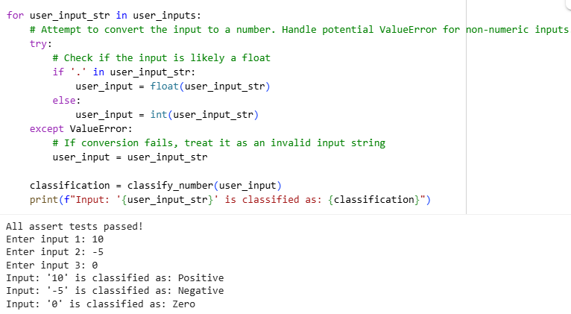

EXPLANATION:

TASK 3:

write a python program to generate at least 3 assert test cases for is_anagram(str1, str2) and implement the function. • Requirements: o Ignore case, spaces, and punctuation. o Handle edge cases (empty strings, identical words).take user 3 inputs

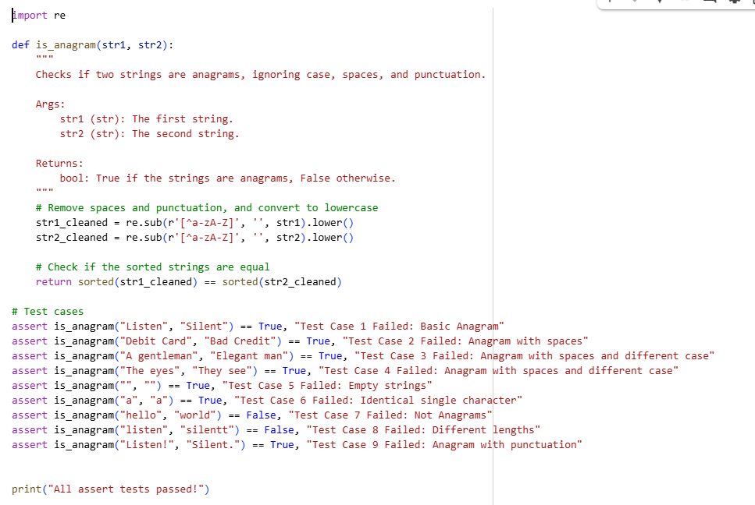

OUTPUT:

EXPLANATION:

TASK 4:

write a python program to generate at least 3 assert-based tests for an Inventory class with stock management. • Methods: o add_item(name, quantity) o remove_item(name, quantity) o get_stock(name).inv = Inventory() inv.add_item("Pen", 10) assert inv.get_stock("Pen") == 10 inv.remove_item("Pen", 5) assert inv.get_stock("Pen") == 5 inv.add_item("Book", 3) assert inv.get_stock("Book") == 3.take 3 user inputs

OUTPUT:

EXPLANATION:

TASK 5:

write a python program to generate at least 3 assert test cases for validate_and_format_date(date_str) to check and convert dates. • Requirements: o Validate "MM/DD/YYYY" format. o Handle invalid dates.take 3 user inputs o Convert valid dates to "YYYY-MM-DD".Take 3 user inputs.

OUTPUT:

EXPLANATION:

